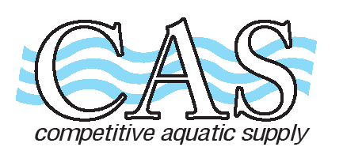
Competitive Aquatic Supply 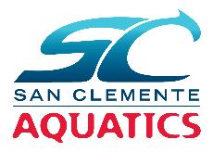
15661 Container Lane
Huntington Beach, Ca 92649
Tel: (714) 898-2655 Fax: (714) 898-4988
www.casswimshop.com

SAN CLEMENTE AQUATICS
Name __________________________________________________ Date _________________________
Address ___________________________________________________ Phone _________________________
City/Zip ___________________________________________________ Email _________________________
Item Qty Size Price Total

SCAT PARENT SPIRIT WEAR

T-Shirts Navy w/ full front logo in white
T-shirt BC3001 NV size XS-XXL ____ ____ $12.00 _______
Ladies V-Neck BC6405 NV size S – XXL ____ ____ $12.00 _______
Ladies Tank BC8800 Heather Navy size XS – XXL ____ ____ $12.00 _______

Sweatshirts Navy
Hoodie BC3719 NV size AS – AXXL ____ ____ $25.00 _______
Zip BC3739 NV front embroidered logo size XS – XXL ____ ____ $30.00 _______

Hats
Trucker Hat VC400 Navy w/embroidered logo ____ ____ $12.00 ________
Baseball Hat SP2150 Navy embroidered logo ____ ____ $12.00 ________
Visor SP2190 Navy w/embroidered logo ____ ____ $12.00 ________

Sub Total ________
Tax 7.75% ________
Total ________

