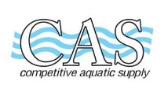 COMPETITIVE AQUATIC SUPPLY 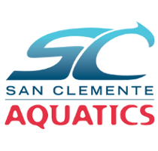
15661 Container Lane
Huntington Beach, CA 92649
714-898-2655 800-421-5192

Name_____________________________________________ Date ______________________________________
Address__________________________________________ Phone _____________________________________
City/Zip _________________________________________ email ______________________________________
ITEM QTY PRICE TOTAL

Bronze (Novice): _____ $24.00 _____
Equip Bag: CAS Mesh Equip Bag w/logo
Fins: CAS Tritan F635
Shoe Size: ___6-8Y ___8-11Y ___11-13Y ___1-3Y
___3-5 ___5-7 ___7-9 ___9-10 ___10-11 ___11-13
Silver 1 (10 & under): ____ $64.00 ______
Equip Bag: CAS Mesh Equip Bag w/logo
Hand Paddle: 71500 XXS
Snorkel: TYR Elite LSNKLELT
Fins: CAS Tritan F635
Shoe Size: ___6-8Y ___8-11Y ___11-13Y ___1-3Y
___3-5 ___5-7 ___7-9 ___9-10 ___10-11 ___11-13
Silver 2 (11 & up): _____ $72.00 ______
Equip Bag: CAS Mesh Equip Bag w/logo
Hand Paddle 0 .5 Strokemaker SMHP
Snorkel: TYR Elite 2.0 LSNRKL
Fins: CAS Tritan F635
Shoe Size: ___6-8Y ___8-11Y ___11-13Y ___1-3Y
___3-5 ___5-7 ___7-9 ___9-10 ___10-11 ___11-13
JO Gold & Senior 2: Option 1 _____ $72.00 ______
Equip Bag: CAS Mesh Equip Bag w/logo
Hand Paddle 0.5 Strokemaker SMHP
Snorkel: TYR Elite 2.0 LSNRKL
Fins: CAS Tritan F635
Shoe Size: ___6-8Y ___8-11Y ___11-13Y ___1-3Y
___3-5 ___5-7 ___7-9 ___9-10 ___10-11 ___11-13

SUBTOTAL ______
TAX 7.75% ______
TOTAL ______

