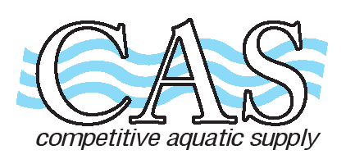
Competitive Aquatic Supply 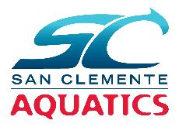
15661 Container Lane
Huntington Beach, Ca 92649
Tel: (714) 898-2655 Fax: (714) 898-4988
www.casswimshop.com
SAN CLEMENTE AQUATICS
Name __________________________________________________ Date _________________________
Address ___________________________________________________ Phone _________________________
City/Zip ___________________________________________________ Email _________________________
Item Qty Size Price Total
TYR Durafast Elite Solid Navy w/logo
Female Maxfit, thick strap, MDUS – 401 size 22-40 _____ _____ $62.95 ________
Female Diamondfit, thin strap, DDUS – 401 size 22-40 _____ _____ $62.95 ________
Female Cutoutfit TFDUS – 401 size 26-38 _____ _____ $62.95 ________
Male Jammer SDUS – 401 sizes 22-38 _____ _____ $47.95 ________ Male Racer RDUS – 401 size 22-38 _____ _____ $36.95 ________
TYR Fusion Navy w/logo
Female Shortjohn ASFUN6 401 size 22 – 38 _____ _____ $97.95 ________
Male Jammer SFUSN6 491 size 20 – 36 _____ _____ $82.95 ________
TYR Team Parka –Navy with front and back logo
WATPM – 401 Unisex (sizes YS-YL & AXS–AXXL) ____ ____ $117.95 _____
WATPF - 401 Female (sizes XS – XL) ____ ____ $117.95 _____
Name: ____________________________________ ____ $ 7.00 _____
TYR Team Warm-Up –Navy w/logo
Male Jacket MTFZH- Navy (sizes YS-YL & AS-AXXL) ____ ____ $72.95 _____
. Male Jogger Pant MTJO- Navy (sizes YS-YL & AS-AXXL) ____ ____ $46.95 _____
Female Jacket WTFZH - (sizes AXS–AXL) ____ ____ $72.95 _____
Female Jogger Pant WTJO - (sizes AXS–AXL) ____ ____ $46.95 _____
Name: _____________________________________ ____ $ 7.00 _____

Team Bag TYR Alliance 45 L Backpack Navy/Whit 112 w/logo _____ _____ $69.95 ________
Name ___________________________________ _____ $ 7.00 ________

Team Apparel with logo
T-shirt G2000 Navy/White size S-XXL ____ ____ $10.00 _______
Hoodie G18500 Navy size YS – YL & AS – AXXL ____ ____ $25.00 _______
Ladies BC6405 V-Neck Navy size S – XXL ____ ____ $12.00 _______

Sub Total ________
Tax 7.75% ________
Total ________

